4. Implement programs to check stationary of a time series data
AIM:
To Implement programs to check stationary of a time series data
PROCEDURE:
1.Import the necessary libraries: 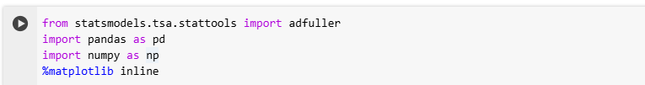
2. Load the dataset :
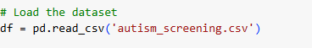
3.Check for the missing values.
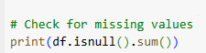
4.Explore the correlation between the numeric column.
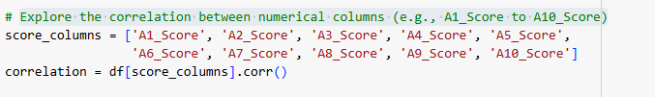
5.Select the numeric column for the ADT test and perform the test.
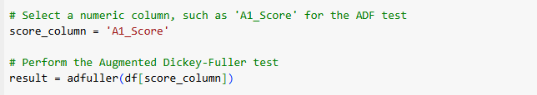

OUTPUT
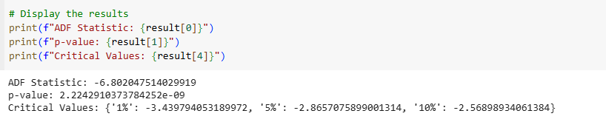
Interpret the final result and check for the stationary
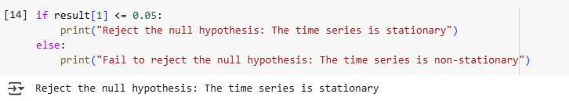

RESULT:
The program to check stationary on the autism screening dataset has been implemented successfully.

